**INDIA GENERAL ELECTIONS RESULT ANALYSIS 2024**

**Total Seats**

SELECT

DISTINCT COUNT (Parliament_Constituency) AS Total_Seats

FROM constituencywise_results



**What is the total number of seats available for elections in each state**

SELECT

s.State AS State_Name,

COUNT(cr.Constituency_ID) AS Total_Seats_Available

FROM

constituencywise_results cr

JOIN

statewise_results sr ON cr.Parliament_Constituency = sr.Parliament_Constituency

JOIN

states s ON sr.State_ID = s.State_ID

GROUP BY

s.State

ORDER BY

s.State;

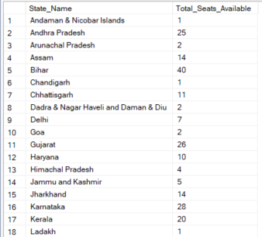 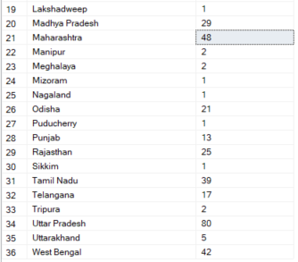

**Total Seats Won by NDA Allianz**

SELECT

SUM(CASE

WHEN party IN (

'Bharatiya Janata Party - BJP',

'Telugu Desam - TDP',

'Janata Dal (United) - JD(U)',

'Shiv Sena - SHS',

'AJSU Party - AJSUP',

'Apna Dal (Soneylal) - ADAL',

'Asom Gana Parishad - AGP',

'Hindustani Awam Morcha (Secular) - HAMS',

'Janasena Party - JnP',

'Janata Dal (Secular) - JD(S)',

'Lok Janshakti Party(Ram Vilas) - LJPRV',

'Nationalist Congress Party - NCP',

'Rashtriya Lok Dal - RLD',

'Sikkim Krantikari Morcha - SKM'

) THEN [Won]

ELSE 0

END) AS NDA_Total_Seats_Won

FROM

partywise_results

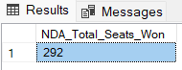

**Seats Won by NDA Allianz Parties**

SELECT

party as Party_Name,

won as Seats_Won

FROM

partywise_results

WHERE

party IN (

'Bharatiya Janata Party - BJP',

'Telugu Desam - TDP',

'Janata Dal (United) - JD(U)',

'Shiv Sena - SHS',

'AJSU Party - AJSUP',

'Apna Dal (Soneylal) - ADAL',

'Asom Gana Parishad - AGP',

'Hindustani Awam Morcha (Secular) - HAMS',

'Janasena Party - JnP',

'Janata Dal (Secular) - JD(S)',

'Lok Janshakti Party(Ram Vilas) - LJPRV',

'Nationalist Congress Party - NCP',

'Rashtriya Lok Dal - RLD',

'Sikkim Krantikari Morcha - SKM'

)

ORDER BY Seats_Won DESC

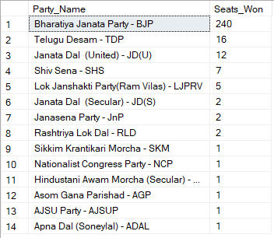

**Total Seats Won by I.N.D.I.A. Allianz**

SELECT

SUM(CASE

WHEN party IN (

'Indian National Congress - INC',

'Aam Aadmi Party - AAAP',

'All India Trinamool Congress - AITC',

'Bharat Adivasi Party - BHRTADVSIP',

'Communist Party of India (Marxist) - CPI(M)',

'Communist Party of India (Marxist-Leninist) (Liberation) - CPI(ML)(L)',

'Communist Party of India - CPI',

'Dravida Munnetra Kazhagam - DMK',

'Indian Union Muslim League - IUML',

'Nat`Jammu & Kashmir National Conference - JKN',

'Jharkhand Mukti Morcha - JMM',

'Jammu & Kashmir National Conference - JKN',

'Kerala Congress - KEC',

'Marumalarchi Dravida Munnetra Kazhagam - MDMK',

'Nationalist Congress Party Sharadchandra Pawar - NCPSP',

'Rashtriya Janata Dal - RJD',

'Rashtriya Loktantrik Party - RLTP',

'Revolutionary Socialist Party - RSP',

'Samajwadi Party - SP',

'Shiv Sena (Uddhav Balasaheb Thackrey) - SHSUBT',

'Viduthalai Chiruthaigal Katchi - VCK'

) THEN [Won]

ELSE 0

END) AS INDIA_Total_Seats_Won

FROM

partywise_results

**Seats Won by I.N.D.I.A. Allianz Parties**

SELECT

party as Party_Name,

won as Seats_Won

FROM

partywise_results

WHERE

party IN (

'Indian National Congress - INC',

'Aam Aadmi Party - AAAP',

'All India Trinamool Congress - AITC',

'Bharat Adivasi Party - BHRTADVSIP',

'Communist Party of India (Marxist) - CPI(M)',

'Communist Party of India (Marxist-Leninist) (Liberation) - CPI(ML)(L)',

'Communist Party of India - CPI',

'Dravida Munnetra Kazhagam - DMK',

'Indian Union Muslim League - IUML',

'Nat`Jammu & Kashmir National Conference - JKN',

'Jharkhand Mukti Morcha - JMM',

'Jammu & Kashmir National Conference - JKN',

'Kerala Congress - KEC',

'Marumalarchi Dravida Munnetra Kazhagam - MDMK',

'Nationalist Congress Party Sharadchandra Pawar - NCPSP',

'Rashtriya Janata Dal - RJD',

'Rashtriya Loktantrik Party - RLTP',

'Revolutionary Socialist Party - RSP',

'Samajwadi Party - SP',

'Shiv Sena (Uddhav Balasaheb Thackrey) - SHSUBT',

'Viduthalai Chiruthaigal Katchi - VCK'

)

ORDER BY Seats_Won DESC

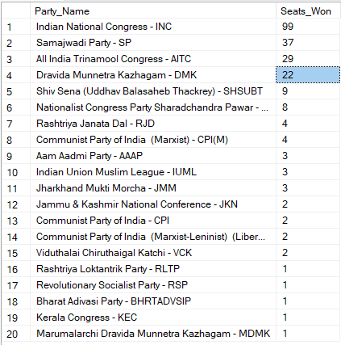

**Add new column field in table partywise_results to get the Party Allianz as NDA, I.N.D.I.A and OTHER**

ALTER TABLE partywise_results

ADD party_alliance VARCHAR(50);

**I.N.D.I.A Allianz**

UPDATE partywise_results

SET party_alliance = 'I.N.D.I.A'

WHERE party IN (

'Indian National Congress - INC',

'Aam Aadmi Party - AAAP',

'All India Trinamool Congress - AITC',

'Bharat Adivasi Party - BHRTADVSIP',

'Communist Party of India (Marxist) - CPI(M)',

'Communist Party of India (Marxist-Leninist) (Liberation) - CPI(ML)(L)',

'Communist Party of India - CPI',

'Dravida Munnetra Kazhagam - DMK',

'Indian Union Muslim League - IUML',

'Jammu & Kashmir National Conference - JKN',

'Jharkhand Mukti Morcha - JMM',

'Kerala Congress - KEC',

'Marumalarchi Dravida Munnetra Kazhagam - MDMK',

'Nationalist Congress Party Sharadchandra Pawar - NCPSP',

'Rashtriya Janata Dal - RJD',

'Rashtriya Loktantrik Party - RLTP',

'Revolutionary Socialist Party - RSP',

'Samajwadi Party - SP',

'Shiv Sena (Uddhav Balasaheb Thackrey) - SHSUBT',

'Viduthalai Chiruthaigal Katchi - VCK'

);

**NDA Allianz**

UPDATE partywise_results

SET party_alliance = 'NDA'

WHERE party IN (

'Bharatiya Janata Party - BJP',

'Telugu Desam - TDP',

'Janata Dal (United) - JD(U)',

'Shiv Sena - SHS',

'AJSU Party - AJSUP',

'Apna Dal (Soneylal) - ADAL',

'Asom Gana Parishad - AGP',

'Hindustani Awam Morcha (Secular) - HAMS',

'Janasena Party - JnP',

'Janata Dal (Secular) - JD(S)',

'Lok Janshakti Party(Ram Vilas) - LJPRV',

'Nationalist Congress Party - NCP',

'Rashtriya Lok Dal - RLD',

'Sikkim Krantikari Morcha - SKM'

);

**OTHER**

UPDATE partywise_results

SET party_alliance = 'OTHER'

WHERE party_alliance IS NULL;

**Which party alliance (NDA, I.N.D.I.A, or OTHER) won the most seats across all states?**

SELECT

p.party_alliance,

COUNT(cr.Constituency_ID) AS Seats_Won

FROM

constituencywise_results cr

JOIN

partywise_results p ON cr.Party_ID = p.Party_ID

WHERE

p.party_alliance IN ('NDA', 'I.N.D.I.A', 'OTHER')

GROUP BY

p.party_alliance

ORDER BY

Seats_Won DESC;

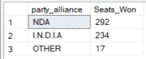

**Winning candidate's name, their party name, total votes, and the margin of victory for a specific state and constituency?**

SELECT cr.Winning_Candidate, p.Party, p.party_alliance, cr.Total_Votes, cr.Margin, cr.Constituency_Name, s.State

FROM constituencywise_results cr

JOIN partywise_results p ON cr.Party_ID = p.Party_ID

JOIN statewise_results sr ON cr.Parliament_Constituency = sr.Parliament_Constituency

JOIN states s ON sr.State_ID = s.State_ID

WHERE s.State = 'Uttar Pradesh' AND cr.Constituency_Name = 'AMETHI';



**What is the distribution of EVM votes versus postal votes for candidates in a specific constituency?**

SELECT

cd.Candidate,

cd.Party,

cd.EVM_Votes,

cd.Postal_Votes,

cd.Total_Votes,

cr.Constituency_Name

FROM

constituencywise_details cd

JOIN

constituencywise_results cr ON cd.Constituency_ID = cr.Constituency_ID

WHERE

cr.Constituency_Name = 'MATHURA'

ORDER BY cd.Total_Votes DESC;

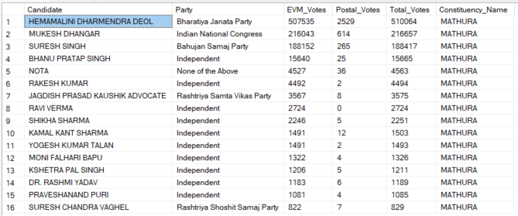

**Which parties won the most seats in s State, and how many seats did each party win?**

SELECT

p.Party,

COUNT(cr.Constituency_ID) AS Seats_Won

FROM

constituencywise_results cr

JOIN

partywise_results p ON cr.Party_ID = p.Party_ID

JOIN

statewise_results sr ON cr.Parliament_Constituency = sr.Parliament_Constituency

JOIN states s ON sr.State_ID = s.State_ID

WHERE

s.state = 'Andhra Pradesh'

GROUP BY

p.Party

ORDER BY

Seats_Won DESC;

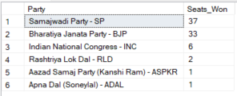

**What is the total number of seats won by each party alliance (NDA, I.N.D.I.A, and OTHER) in each state for the India Elections 2024**

SELECT

s.State AS State_Name,

SUM(CASE WHEN p.party_alliance = 'NDA' THEN 1 ELSE 0 END) AS NDA_Seats_Won,

SUM(CASE WHEN p.party_alliance = 'I.N.D.I.A' THEN 1 ELSE 0 END) AS INDIA_Seats_Won,

SUM(CASE WHEN p.party_alliance = 'OTHER' THEN 1 ELSE 0 END) AS OTHER_Seats_Won

FROM

constituencywise_results cr

JOIN

partywise_results p ON cr.Party_ID = p.Party_ID

JOIN

statewise_results sr ON cr.Parliament_Constituency = sr.Parliament_Constituency

JOIN

states s ON sr.State_ID = s.State_ID

WHERE

p.party_alliance IN ('NDA', 'I.N.D.I.A', 'OTHER') -- Filter for NDA and INDIA alliances

GROUP BY

s.State

ORDER BY

s.State;

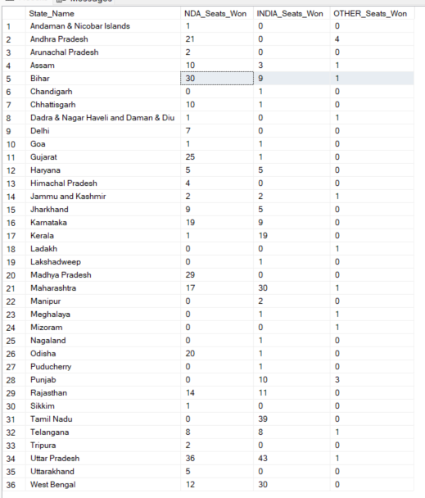

**Which candidate received the highest number of EVM votes in each constituency (Top 10)?**

SELECT TOP 10

cr.Constituency_Name,

cd.Constituency_ID,

cd.Candidate,

cd.EVM_Votes

FROM

constituencywise_details cd

JOIN

constituencywise_results cr ON cd.Constituency_ID = cr.Constituency_ID

WHERE

cd.EVM_Votes = (

SELECT MAX(cd1.EVM_Votes)

FROM constituencywise_details cd1

WHERE cd1.Constituency_ID = cd.Constituency_ID

)

ORDER BY

cd.EVM_Votes DESC;

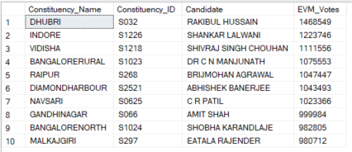

**Which candidate won and which candidate was the runner-up in each constituency of State for the 2024 elections?**

WITH RankedCandidates AS (

SELECT

cd.Constituency_ID,

cd.Candidate,

cd.Party,

cd.EVM_Votes,

cd.Postal_Votes,

cd.EVM_Votes + cd.Postal_Votes AS Total_Votes,

ROW_NUMBER() OVER (PARTITION BY cd.Constituency_ID ORDER BY cd.EVM_Votes + cd.Postal_Votes DESC) AS VoteRank

FROM

constituencywise_details cd

JOIN

constituencywise_results cr ON cd.Constituency_ID = cr.Constituency_ID

JOIN

statewise_results sr ON cr.Parliament_Constituency = sr.Parliament_Constituency

JOIN

states s ON sr.State_ID = s.State_ID

WHERE

s.State = 'Maharashtra'

)

SELECT

cr.Constituency_Name,

MAX(CASE WHEN rc.VoteRank = 1 THEN rc.Candidate END) AS Winning_Candidate,

MAX(CASE WHEN rc.VoteRank = 2 THEN rc.Candidate END) AS Runnerup_Candidate

FROM

RankedCandidates rc

JOIN

constituencywise_results cr ON rc.Constituency_ID = cr.Constituency_ID

GROUP BY

cr.Constituency_Name

ORDER BY

cr.Constituency_Name;

